**SANDBOX COLLECTIVE THEATRE IN SCHOOL PROJECT REPORT 2019-2020**

**About the engagement**

Theatre unravels in time and space. It is all consuming and all engaging. Theatre deals with human relations as existed at a given set of period in time. So to know about theatre is to know the traditions, customs, manners and behavioural patterns.

Theatre at the individual level is a process of understanding one’s own self and expanding one’s horizons at the same time. Through the workshop, students are encouraged to reconnect with themselves and their emotions, with the aim of ultimately improving their self-esteem.

This approach increases student’s abilities to tell their stories, solve problems, set goals and to express feelings appropriately. It is also a tool used to extend the depth and breadth of inner experiences, improve interpersonal skills and relationships, and strengthen the ability to perform personal life roles. The methodology used also encourages students to establish a work routine and discipline, in order to stage a performance.

Since a play is most effectively staged if you work with others, equally relying on each other in coordination and complicity, the theatre workshops contribute to enhancing team work and to developing a stronger and positive bond with the youth’s peers and the adults involved.

**Objectives of the Program**:

1. To develop trust and confidence in self and peer groups through acting, improvisations, performances and discussions.
2. To overcome inhibitions, stage fear and social restrictions.
3. To develop effective verbal and non-verbal communication skills.
4. To explore stories, narratives of their own life and imagination.
5. Reflect upon one’s thoughts, skills and identify areas of interest.
6. To develop skills of effective communication, dynamic leadership through problem solving, critical thinking and decision-making, ability to think creatively and act confidently.

Activities conducted to achieve the said goals along with comments and reflections from the RP are detailed out session wise.

|  |  |  |  |  |
| --- | --- | --- | --- | --- |
| **No** | **Date** | **# Students** | **Activity** | **RP & Observer Comments** |
| **Government Higher Primary Girls School, Sarjapura** | | | | |
| 1 | 18-12-2019 | 33 | Simulative and challenging games - number games, memories games | very disciplined children and everyone wants to learn more |
| 2 | 20-12-2019 | 31 | physical exercises to improve body awareness and control and 2 games | very humble children and learn well, so much enthusiasm is there . |
| 3 | 21-12-2019 | 29 | body language exercises including posture facial expressions gestures movement - 2 games and tattu chappale, ajjana kolu songs | I am while taking classes in this school so much supportive |
| 4 | 08-01-2020 | 33 | voice exercise eh :- volume, pitch etc - Aane bandittu song | all are very excited to learn songs and learn well |
| 5 | 10-01-2020 | 33 | Speaking - pronunciation - own story telling | own story telling session sessions done well in this school |
| 6 | 11-01-2020 | 32 | pair and group activities, group song, Crafts work - Cap making and dustbins making | group activities engage well craft work session learn well and extra songs also learn lot of time remaining because these children are very fast |
| 7 | 13-01-2020 | 31 | pair and group activities, group songs, Crafts work - Cap making and dustbins making | group activities engage well craft work session learn well |
| 8 | 17-01-2020 | 30 | writing narratives - Own story writing session with help of 10-12 things | children are excited and writing sessions are done well need extra time to explore stories |
| 9 | 18-01-2020 | 31 | reading, recitation, narration - own story telling and make small skit | this session conducted very and Start one small skit this school |
| 10 | 18-01-2020 | 31 | reading, recitation, narration - own story telling and make small skit | skit continued in school and done well |
| 11 | 27-01-2020 | 31 | Speaking - pronunciation - own story telling - songs | speaking task and song singing sessions are do well and all are very interested kids and very happy to take classes in this school |
| 12 | 29-01-2020 | 29 | exploring each other narratives and coming up with the mime act | mime act done well children learn well and co operate well |
| 13 | 31-01-2020 | 30 | exploring each other narratives and coming up with the mime act | narrative classes done well and mime act with different imagination things |
| 14 | 03-02-2020 | 31 | exploring each other narratives and coming up with the mime act | narrative classes done well and mime act with different imagination things |
| 15 | 05-02-2020 | 27 | using available resources to perform the play - newspaper scene, market scene, police station scene | this school are very well co operated and done well |
| 16 | 07-02-2020 | 27 | rehearsals - songs, drama and all activities | they were very much invested in the performance. They all remembered their dialogues and rehearsals went very well |
| 17 | 08-02-2020 | 26 | rehearsals - songs, drama and all activities | they were very much invested in the performance. They all remembered their dialogues and rehearsals went very well |
| 18 | 11-02-2020 | 26 | rehearsals - songs, drama and all activities | they were very much invested in the performance. They all remembered their dialogues and rehearsals went very well |
| 19 | 12-02-2020 | 27 | rehearsals - songs, drama and all activities | mask making workshop done easily because all children learn well |
| 20 | 14-02-2020 | 26 | mask making, mask painting | mask making workshop done easily because all children learn well |
| 21 | 14-02-2020 | 26 | mask making, mask painting | mask making workshop done easily because all children learn well |
| 22 |  |  | **Final Performance** |  |
| **Government Higher Primary Boys School, Sarjapura** | | | | |
| 1 | 16-12-2019 | 25 | Simulative and challenging games - number games, memories games | Most of the students are super active, and difficult to get them to listen to instructions and settle them down. Observations during other classes showed that they tend to behave similarly in other classes as well, teacher find it difficult to get them. It seems like students have not developed the practise of respecting or giving any regards to the teachers |
| 2 | 18-12-2019 | 24 | physical exercises to improve body awareness and control and 2 games | efforts to get students to listen to instructions is still on. lot of disturbances in this school and will need time to cover up A lot of time goes into getting students to be seated in place |
| 3 | 20-12-2019 | 21 | body language exercises including posture facial expressions gestures movement - 2 games and tattu chappale, ajjana kolu songs | More students are participating. Half of them learn songs very well and half of them leant and write songs, while few students continue to be trouble makers. |
| 4 | 06-01-2020 | 21 | voice exercise eh :- volume, pitch etc - Aane bandittu song | compared to last class children behaving better and learnt the song well |
| 5 | 06-01-2020 | 26 | Speaking - pronunciation - own story telling | Children were very much involved in making their own story and sharing. Had not expected such good participation. |
| 6 | 08-01-2020 | 21 | pair and group activities, group songs, Crafts work - Cap making and dustbins making | engaged well in group activities for craft work |
| 7 | 10-01-2020 | 24 | pair and group activities, group songs, Crafts work - Cap making and dustbins making | Children engaged very well in pair activities, but few of them were disinterested |
| 8 | 13-01-2020 | 26 | writing narratives - Own story writing session with help of 10-12 things | Students were very creative in personifying objects around them and share stories. However a handful children were difficult to engage with. |
| 9 | 17-01-2020 | 25 | reading, recitation , narration - own story telling and make small skit | There was low energy in the class, there was a challenge in engaging them. |
| 10 | 22-01-2020 | 14 | Speaking - pronunciation - own story telling- songs | Too much disturbance in the school and children were not willing to listen to the RP. |
| 11 | 22-01-2020 | 14 | Speaking - pronunciation - own story telling - songs | It seemed like children are picking up the rules of the class, and learning to behave better. there was a drastic change in their behaviour. |
| 12 | 27-01-2020 | 13 | Speaking - pronunciation - own story telling - songs | there was less disturbance comparatively |
| 13 | 29-01-2020 | 20 | exploring each other narratives and coming up with the mime act | children learnt well and co operated well in building narratives |
| 14 | 31-01-2020 | 17 | exploring each other narratives and coming up with the mime act | narrative classes done well and mime act with different imagination things |
| 15 | 03-02-2020 | 14 | exploring each other narratives and coming up with the mime act | children continued to build from the last class and behaved well as well. |
| 16 | 05-02-2020 | 21 | using available resources to perform the play - newspaper scene, market scene, police station scene | children found this activity a little difficult, but put their best to put together the scene. |
| 17 | 07-02-2020 | 23 | rehearsals - songs, drama and all activities | Children were enthusiastic about the rehearsals and excited about the final performance |
| 18 | 12-02-2020 | 23 | mask making, mask painting | We saw teachers also engaging in this session. This was quite surprising to see them invested. Everybody enjoyed this session. |
| 19 | 15-02-2020 | 18 | mask making, mask painting | Teachers continued to engage in this session. This was quite a boost and added more meaning to the whole engagement. Everybody enjoyed this session. |
| 20 |  |  | **Final Performance** |  |
| **Government Higher Primary School, Mullur** | | | | |
| 1 | 17-12-2019 | 17 | Simulative and challenging games - number games , memories games | children were less enthusiastic about the engagement, They also seemed low on energy. |
| 2 | 19-12-2019 | 16 | physical exercises to improve body awareness and control and 2 games | children are taking time to open up and participate fully |
| 3 | 21-12-2019 | 15 | body language exercises including posture facial expressions gestures movement - 2 games and tattu chappale, ajjana kolu songs | Children have begun to participate to an extent. So much better than previous class |
| 4 | 07-01-2020 | 14 | voice exercise eh :- volume, pitch etc - Aane bandittu song | Surprisingly children learnt the song and also put it into performance. They were so clear about blocking (stage positions/presence) for the song performance. |
| 5 | 09-01-2020 | 17 | Speaking - pronunciation - own story telling | own story telling session sessions done well in this school |
| 6 | 11-01-2020 | 16 | pair and group activities, group songs, Crafts work - Cap making and dustbins making | group activities engage well craft work session learn well |
| 7 | 14-01-2020 | 16 | pair and group activities, group songs Crafts work - Cap making and dustbins making | pair activities and group activities engage well craft work session learn well |
| 8 | 16-01-2020 | 16 | writing narratives - Own story writing session with help of 10-12 things | writing sessions are done well, need extra time to explore stories |
| 9 | 21-01-2020 | 16 | reading, recitation, narration - own story telling and make small skit | small skit this school children done well and create own story make skit very well |
| 10 | 28-01-2020 | 16 | exploring each other narratives and coming up with the mime act | children learn well and co operate well |
| 11 | 30-01-2020 | 15 | exploring each other narratives and coming up with the mime act | narrative classes done well and mime act with different imagination things |
| 12 | 04-02-2020 | 15 | using available resources to perform the play- newspaper scene, market scene, police station scene | create new paper scene very well |
| 13 | 04-02-2020 | 15 | using available resources to perform the play- newspaper scene, market scene, police station scene | create police station scene also done well by children only |
| 14 | 06-02-2020 | 16 | using available resources to perform the play- newspaper scene, market scene, police station scene | to build new scene and children co operate well |
| 15 | 06-02-2020 | 16 | using available resources to perform the play- newspaper scene, market scene, police station scene | class continued |
| 16 | 08-02-2020 | 11 | rehearsals - songs, drama and all activities | Children remembered all their dialogues well and very invested in the rehearsals. |
| 17 | 11-02-2020 | 14 | rehearsals - songs, drama and all activities | Children remembered all their dialogues well and very invested in the rehearsals. |
| 18 | 13-02-2020 | 14 | rehearsals - songs, drama and all activities | mask making workshop done easily because all children participated well |
| 19 | 13-02-2020 | 14 | mask making, mask painting | mask making workshop done easily because all children participated well |
| 20 | 15-02-2020 | 12 | mask making, mask painting | mask making workshop done easily because all children participated well |
| 21 |  |  | **Final performance** |  |
| **Government Higher Primary School, Krishnappanagar** | | | | |
| 1 | 17-12-2019 | 24 | Simulative and challenging games - number games , memories games | Good supportive children and very well disciplined |
| 2 | 19-12-2019 | 24 | physical exercises to improve body awareness and control and 2 games | these are quick learners and very attentive in class |
| 3 | 21-12-2019 | 24 | body language exercises including posture facial expressions gestures movement - 2 games and tattu chappale, ajjana kolu songs | expression activities done well and these children played games and sing very good |
| 4 | 07-01-2020 | 24 | voice exercise eh :- volume, pitch etc - Aane bandittu song | performed better than last time with making the improvisations that was suggested by the RP. That is very good indicator of their interest and investment in class |
| 5 | 07-01-2020 | 24 | Speaking - pronunciation - own story telling | own story telling session. Children were very much involved in this |
| 6 | 09-01-2020 | 22 | pair and group activities, group songs, Crafts work - Cap making and dustbins making | group activities engage well craft work session(cap and dustbin making) learn well |
| 7 | 10-01-2020 | 22 | pair and group activities, group songs ,Crafts work - Cap making and dustbins making | group activities engage well craft work session learn well |
| 8 | 14-01-2020 | 23 | writing narratives - Own story writing session with help of 10-12 things | writing sessions are done well need extra time to explore stories |
| 9 | 16-01-2020 | 24 | reading, recitation , narration - own story telling and make small skit | narration session very well in this school and lot of improvement in this children. |
| 10 | 21-01-2020 | 23 | Speaking - pronunciation - own story telling – songs | own story telling session will done very well all are supported very well and some children said we want song so la la la song will teach. and they enjoyed |
| 11 | 30-01-2020 | 21 | exploring each other narratives and coming up with the mime act | children learn well and co operate well |
| 12 | 30-01-2020 | 21 | exploring each other narratives and coming up with the mime act | narrative classes done well and mime act with different imagination things |
| 13 | 31-01-2020 | 20 | using available resources to perform the play- newspaper scene, market scene, police station scene | create new paper scene very well |
| 14 | 31-01-2020 | 20 | using available resources to perform the play- newspaper scene, market scene, police station scene | and create police station scene also done well by children only |
| 15 | 06-02-2020 | 21 | using available resources to perform the play- newspaper scene, market scene, police station scene | police station scene done well and lot of mime act narratives skills done well |
| 16 | 06-02-2020 | 21 | using available resources to perform the play- newspaper scene, market scene, police station scene | continued class |
| 17 | 07-02-2020 | 20 | using available resources to perform the play- newspaper scene, market scene, police station scene | created scene and created solo mime acts with Children who performed excellently |
| 18 | 07-02-2020 | 20 | using available resources to perform the play- newspaper scene, market scene, police station scene | class continued |
| 19 | 14-02-2020 | 22 | mask making, mask painting | mask making workshop done easily because all children learn well |
| 20 | 14-02-2020 | 22 | mask making, mask painting | mask making workshop done easily because all children learn well |
| 21 |  |  |  |  |

**Numbers impact:**

We have conducted a total of 84 sessions across the four schools, including the performance in 3 of the schools. We had a total of 100 students participating from all four schools.

**Baseline and Endline comparison**

We had a set of 5 self-assessment questions that was given to the students. These questions were framed to assess student’s participation, self-confidence, sharing responsibilities team work spirit, and leadership initiatives. The questions were mapped to the objectives set out in the beginning of the program.

For baseline we had 101 students participate, however we could only collect endline data for 54 students. Reason for this was the unprecedented close down of schools due to the pandemic COVID 19 spread. So for the purpose fo comparision the data of only those students whose baseline and endline is compiled is taken into consideration.

**Data triangulation**

Self assessment data was collected by children as we believe they know the best about themselves. Also it theatre involves embodies cognition, it would be only false if an external person tries to make any conclusions about the child based on first impressions. However the data that children provided was triangulated by asking teachers to fill in their observations and comments about the children. Teachers were however able to only share few anecdotes or aspects. The observer and RPs had compiled journal entries of all the children, ensuring atleast there is one entry of each of the child. This has helped us capture any single trait or the holistic growth of the child. We have also collected verbal responses from students about their participation in the workshop over the 20 sessions. A consolidation of children’s self assessment, teacher’s comments and RP’s/observers comment have been put together to share stories/anecdotes. All of these raw data is shared as well.

**The baseline and endline comparision are shown in the pie chart below.**

From the chart below it is very evident that there is a significant change in children’s perception of their participation in the classroom. The first chart on the question if they feel shy to talk in the groups: 30% of children have moved from being shy always /sometimes to never being shy

For the question on their confidence to speak in class, ~ 30 % increase in the number of students who can speak confidently.

In terms of students asking for doubts in the classroom, again there is 25% increase in the number of students who ask doubts if they have any always, and the percent of student who dont ask doubts has reduced from 7% to 2%

There is a shift in students taking responsibility as well, like the students hesitation to take responsibility has reduced from 13% to 4%

And students willingness to work with other students has also increased with 7% more students willing to work with others always and reduce of students hesitation from 9% to 7%

**Stories of change**

**GHPS Mullur**

**Student1**

Nageshwari is a student from GHPS Mullur who sometimes shied away from sometimes to talk in a group and could manage to talk confidently in class when at the beginning of the session. This had changed to the student never shying away to taking in a group and always confident while talking in the class at the completion of the theatre program.

The child who had expected drama performance to learn in the course of the program enjoyed many theatre songs and loved singing them. She enjoyed singing the group and community songs. The Resource Person found the girl very actively participating in all the activities during the program.

**Student 2**

Mallamma is another student from GHPS Mullur who sometimes shied away from sometimes to talk in a group and could manage to talk confidently in class when at the beginning of the session. This had changed to the student never shying away to talking in a group and always confident while talking in the class at the completion of the theatre program.  In addition to the above Mallamma , who never liked taking responsibility in the class had developed into the student who enjoyed and looked forward to taking responsibilities.

According to the Resource Persons, the child who seemed shy showed difficulty in learning had developed into someone taking many initiatives in class by the end of the program.

**Student 3**

Bharata is a special child with mental challenges. He always had difficulty in talking in a group and could never talk with confidence in class. It was heartening to see the child change speaking without hesitation in groups and talk with some confidence in class. This was a significant change considering the treatment the child was subjected to by other children and often to the anger of the teachers too. He as constantly neglected, made fun of and looked down upon. The child did not have happy reasons to come to the class in general.

The theatre program provided voice, and expression starting with the *Lalala* song that he would go on to greet the Resource Person in every class after it was taught. He particularly showed an aptitude and interest in clowning(buffoonery) which explored narration through comedy. He was a very quiet kid who did not seem to have general conversations with his classmates. He was seen looking forward to the theatre class and would, of course, be greeted by the *Lalala* song which was a song of just sounds. The child still had difficulty in learning some songs that had more words and text but would join in humming the tune with everyone.

Initially, the other children were not willing to have Bharat be part of the class as they felt he would not participate and only disturb. He was as told by others made to sit down away from others in the other classes too. Theatre Program class participation had other children joining Bharata in theatre games, Bharata enjoying with others. Space had slowly changed to welcome and make him part of everyone too and Bharata had started making his own space among others.

**Student 4**

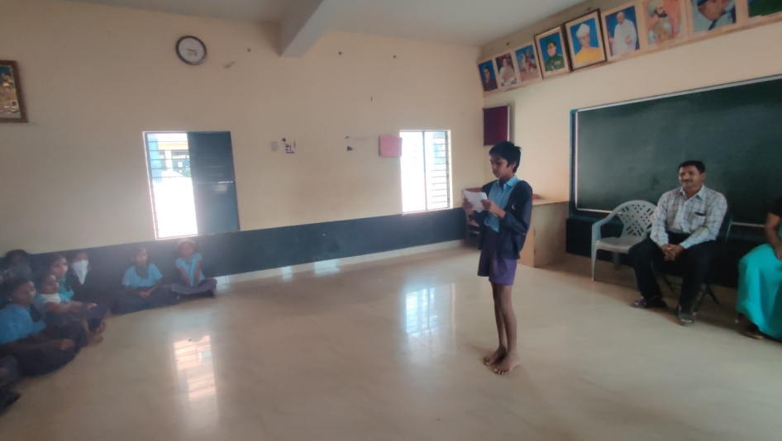Rakesh P M as a student was hesitant in the class to participate in the activities.  He also hesitated to speak in a group and managed only sometimes to ask questions confidently to clarify in a class. Rakesh was seemed to develop confendence in talking to others without any hesitations and ask any question confidently. Rakesh eventually went on to host the final performance and did it with so much confidence! The school teachers were pleased to see him host the event as they had never seen him get on the stage for anything until then. They had discovered a charming host in Rakesh and looked forward to having him host other programs in school going forward.

Rakesh anchoring the final performance at the end of the Theatre Program.

**GHPS Krishnappanagar**

**Student 1**

Bagyashree as a student was always very hesitant to talk in group and class first set of classes she displayed a lack of confidence. However after a few sessions and gradual growth of trust in other participants, facilitator she enjoyed singing theatre songs and also began helping other students learn the songs. There was increased confidence in her and the joy of doing what she had got a taste of that she was good at.

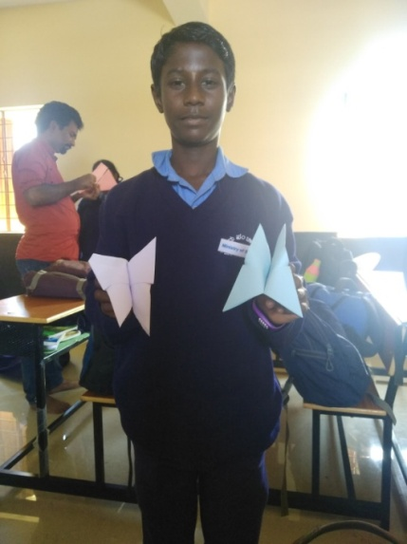**Student 2**

Devraj is a student with lot of eagerness to learn. Devraj participated in all the activities and always wanted more. He would learn a song, a craft and would help others learn and lead smaller learning circles in the classrooms helping others. As he narrated himself, he had always wanted to learn to act and perform but never knew how. The fact that there was no worry of failing and scolding from the resource persons encouraged him greatly and filled him with much more confidence to try everything that came his way with much ease.

Devraj with his butterflies during a story building session

**Student 3**

Jyothi was an introvert, quiet child with hardly any friend. She hesitated a lot in to talk in groups, could not easily talk in class or ask questions confidently to seek any clarification. She did not show much interest in the activities in the beginning. As classes progressed she started liking so much that she would ask for more songs even as the class ended and asked for a longer time and more songs.

**GHPBS Sarjapura**

**Student 1**

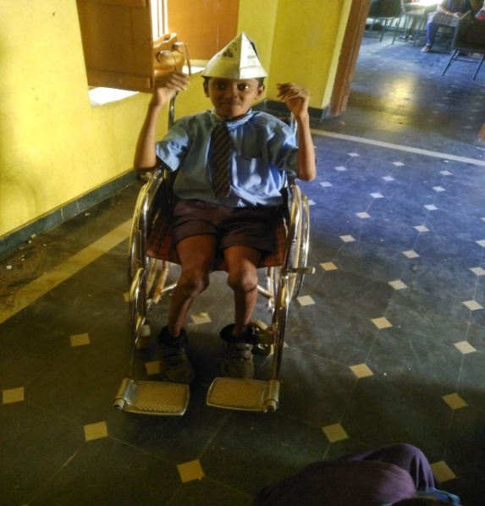Manu K is a student with physical challenge and limited by wheelchair for most physical activities. He said he was always hesitant in talking in class. He participated with great enthusiasm in whatever ways he could. He had developed into confidence child who could ask any question. He had a keen sense of observation. He could in fact remember the name of every resource person who taught him or had accompanied the facilitator/teacher while nearly no one got the names right.

Figure :Manu after papercraft session with a cap of his own

.

**Student 2**

Vijay M is an aggressive child for his age. He initially did not attend the Theatre classes too regularly. However, he found something interesting in the mime classes for him. He liked it so much that with some help from Resource Persons and practice, he developed a solo mime act performance and performed it during the course of the program. The appreciation he received encouraged him to take leadership role in future classes. He would be seen asking other children to not miss classes and to be more attentive.

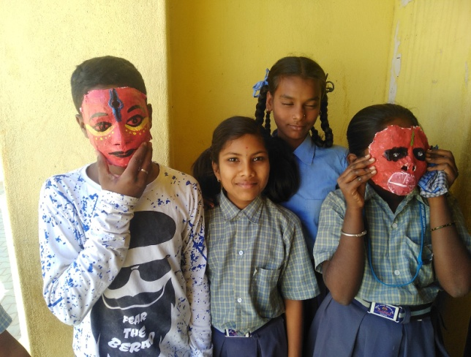  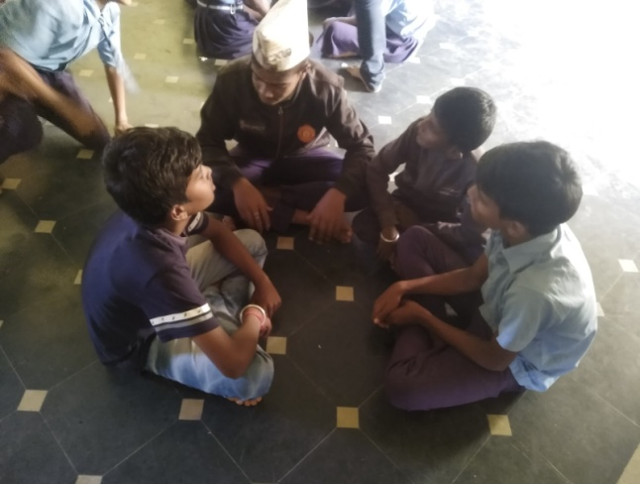

Vijay(1st from Left) in Picture 1 during a mask-making workshop and (With the cap on)in Picture 2 during story development session after the papercraft session.

**Student 3**

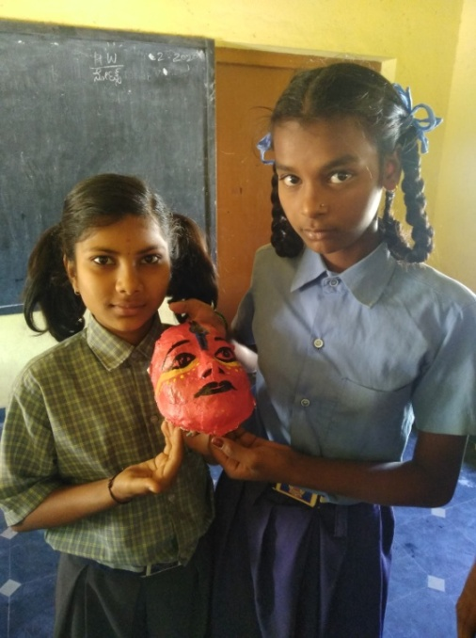Sneha is a student who never had participated in drama or singing though she always wanted to do it herself. She felt she could not do it because she did not know to learn and there was no opportunity either. The Theatre in Schools  Program helped Sneha to learn to act, to sing and provided space to perform. As a student who could seldom talk confidently in class and ask questions to clarify she found the confidence to talk confidently and ask anything with confidence in the class. This was one of the toughest schools where the majority of students were aggressive and often displayed violent behaviour. Sneha wanted the theatre classes to continue and not be disturbed for any reason. She would talk to the students who would disturb and try calming them down.

Sneha(first from left) with her mask during mask making session

**GMPGS Sarjapura**

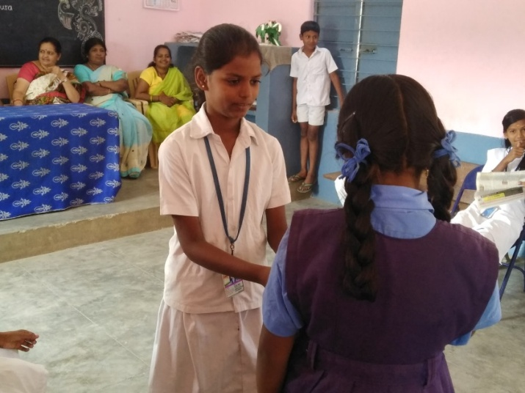**Student 1**

Figure :Saniya play constable role during Police station drama in final performance day in front of audions in which included surprises to teachers

Saniya was a kid who for about initial 5-6 sessions had been very shy to participate. She however slowly opened herself up to participate in all activities. She particularly showed interest in learning songs, found her voice and expression through singing. She was part of the 2 out of 6 small plays done during the Theatre program. The teachers said they were surprised to see Saniya on stage and see her talk with such good clarity of voice and confidence.

**Student 2**

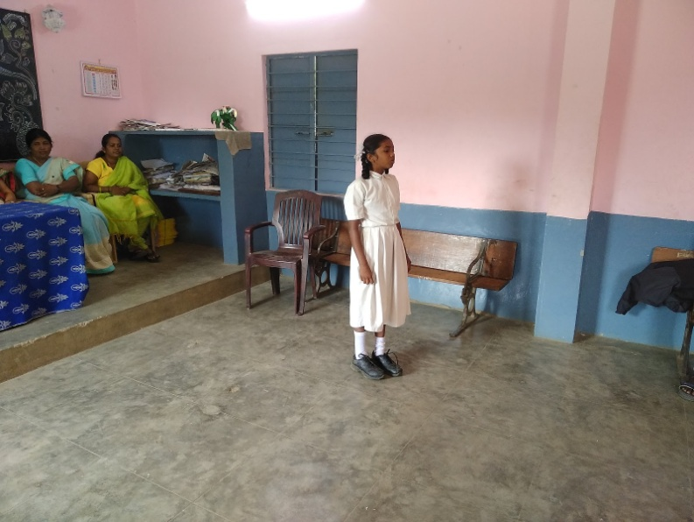Janaki is a very quiet student, who was considered by mostly dull, with very less comprehension skills and poor memory by her school teachers. She showed a lot of hesitation too in the initial classes to participate in the activities. She however slowly found joy in telling stories, in creating stories and developing them. She went on to write her own story called “Paapa Peepu” and narrated the story in front of the class and then for the audience later. The story was that of two girls Paapa and Peepu and Janaki narrated so beautifully that the listeners were enchanted by that. The teachers were absolutely surprised by Janaki’s story and narration skills.

Janaki Narrating her story during the final Performance.

The teachers shared a photo of Janaki further developing the story and narrating it during one of their exhibitions under a new title “Raani-Raami Kathe”. For Janaki, she found 2-3 sessions in a week was not enough and asked if the Theatre Program could be every day throughout the year.

**Student 3**

Suman Baanu was another student who was said by her teachers to be very quiet and would not read when asked to in the class. She seemed a little hesitant too in the initial Theatre classes. However, she was soon seen reading the dialogues, recite during the voice and speech sessions enjoying herself. She could keep the audience engaged with her speech and dialogue delivery. She took part in the plays with great interest and had surprised her teachers with her skill to recite, say dialogues with ease.

She could never had enough of the Theatre classes and would be seen asking for more crafts, songs even after the sessions were over. She would practice them at home, bring her works which she had perfected with practice and was looking for more.

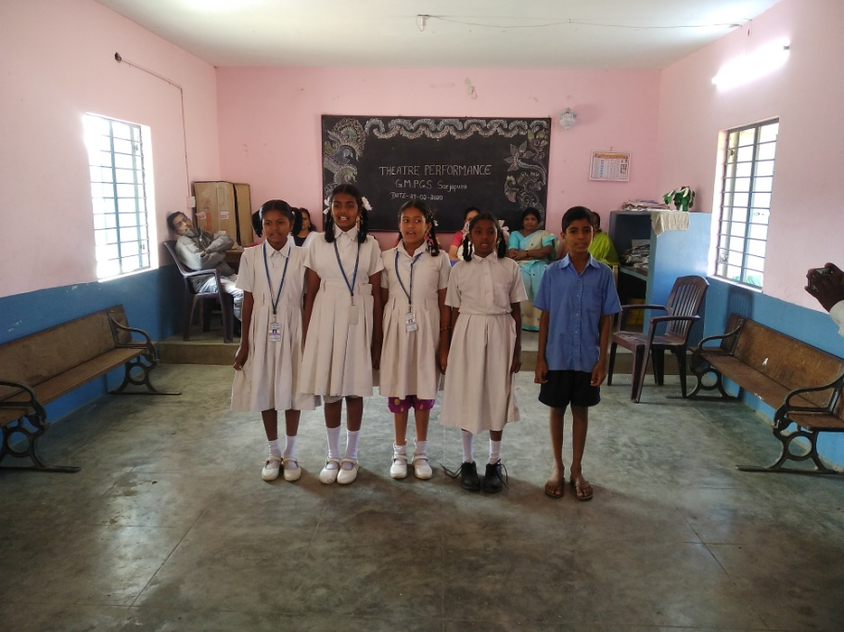

Figure : Sumana Baanu, thrid from the Left singing during the final performance.

**Challenges and Reflections**

Challenges in Theatre classes can be many times case by case. It can range from the availability of resource – space for the classes to many individual specific to participants.

Except GMPGS, Sarjapura, most schools had the evident use of stick and slap to control kids. Children, the assigned monitors too would resort to sticks and threatening to control the class or engage in anything. Further bullying, small fights were common practices in these schools.

Creating a space of open and no fear is the first step for a Theatre program to happen. To bring all the children together to talk, discuss and open to talk, to listen and allow for everyone to be. In Krishnappa Nagar School, one such fight was taken to discussion during a session of how to be in stage, in a space that is shared, of creating of mutual and inclusive space allowing for dialogue to happen. After a few days the students in this school would come and share how they felt bad about the fights they had earlier and they would try to avoid them and would try solving differences and problems through talking and discussion.

Another challenge was the duration of the session, frequency of the sessions. Considering the academic and time needed for completion of the other fulfilments of the school, a planned time during the mid-term session can be workable for students, school and the program. A continuous engagement with the same set of students for about 3 years can have a deeper impact with much more specifically planned session with each participant’s need addressed to and monitored.